9.12 Main question

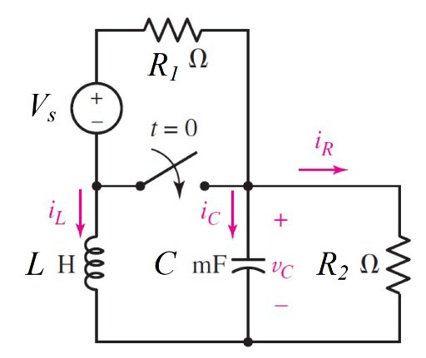

Given vs = 6 V, r1= 20 kΩ, r2= 0.1 Ω, c = 250 mF, l= 2/13 H

Find

Variables

Random variables

#l < 4*r*r*c Parallel, c < 4*r*r/l Series

vs = {1:10};

r1 = {10000:30000:1000};

r2 = {0.1:0.5:0.1};

c = {50e-3:250e-3:50e-3};

l = {1/13:5/13:1/13};

Global variables

#vs = 6; r1 = 20000; r2 = 0.1; c = 0.25;

l = 2/13; time = 1;

# t = 0-

il0 = - vs/(r1+r2);

vc0 = r2/(r1+r2)*vs;

# t = 0+

rth = r2;

alpha = 1/(2*rth*c);

w0 = 1/sqrt(l*c);

S1 = -alpha+sqrt(alpha*alpha-w0*w0);

S2 = -alpha-sqrt(alpha*alpha-w0*w0);

ir = vc0/r2;

ico = -il0-ir;

A1 = ((ic0/c)-(S2*vc0))/(S1-S2);

A2 = vc0-A1;

vct = A1exp(S1*time)+A2exp(S2*time);

Part (กรอกคำตอบ)

1. *vc*(0-) = vc0 = 0.03 mV

2. *vc*(0+) = vc0 = 0.03 mV

3. *α* = alpha = 20 s^-1

4. *ω*0 = w0 = 5.1 rad/s

At *t* > 0

5. *vc*(*t*) = A1exp(S1*t)+A2exp(S2*t)

= 3.05x10-5exp(-0.66*t)- 5.1x10-7exp(-39.34*t) V

6. *vc*(time*τ*) = vct = 1.576x10-5 V

9.16 Main question

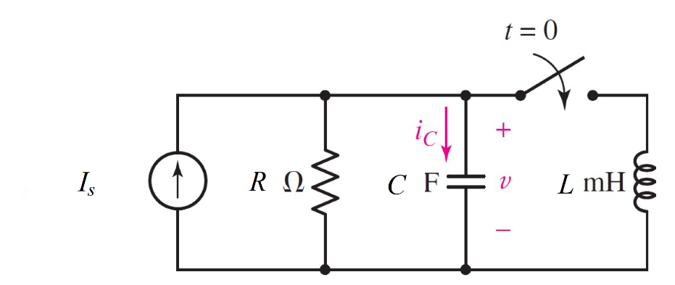

Given Is = 5 *u(-t) µA*, r= 0.2 Ω, c = 4 mF, l= 1 mH

Find

Variables

Random variables

#l < 4*r*r*c Parallel, c < 4*r*r/l Series

is = {1:20};

r = {0.1:2:0.1};

l = {0.001:1:0.001};

c = {0.004:0.02:0.0004};

Global variables

#is = 5e-6; r = 0.2; c = 0.004;

l = 0.001; time = 0.01;

# t = 0-

il0 = 0;

v0 = is*r;

# t = 0+

rth = r;

alpha = 1/(2*rth*c);

w0 = 1/sqrt(l*c);

S1 = -alpha+sqrt(alpha*alpha-w0*w0);

S2 = -alpha-sqrt(alpha*alpha-w0*w0);

ir = vc0/r;

ico = -il0-ir;

A1 = ((ic0/c)-(S2*vc0))/(S1-S2);

A2 = vc0-A1;

vct = A1exp(S1*time)+A2exp(S2*time);

Part (กรอกคำตอบ)

1. *vc*(0-) = vc0 = 0.001 mV

2. *vc*(0+) = vc0 = 0.001 mV

3. *α* = alpha = 625 s^-1

4. *ω*0 = w0 = 500 rad/s

At *t* > 0

5. *vc*(*t*) = A1exp(S1*t)+A2exp(S2*t)

= -0.33x10-6exp(-250*t)- 1.333x10-6exp(-1000*t) V

6. *vc*(time*τ*) = vct = 2.714x10-8 V

9.17 Main question

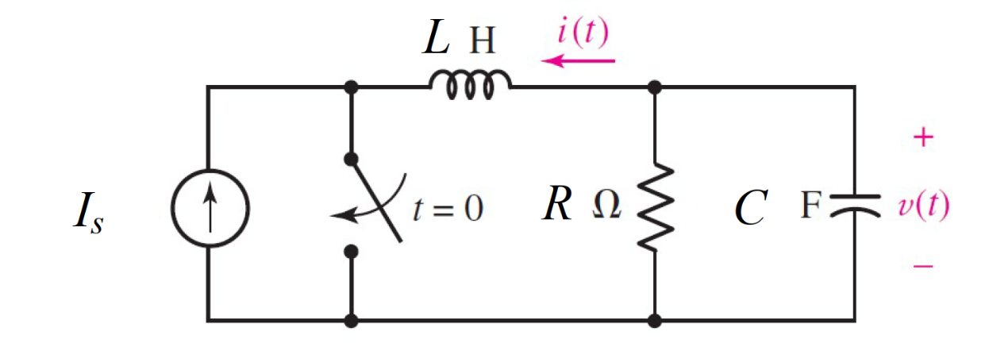

Given Is = 310 *mA*, r= 14 Ω, c = 360 µF, l= 1 H Find

Variables

Random variables

#l < 4*r*r*c Parallel, c < 4*r*r/l Series

is = {0.1:0.4:0.01};

r = {1:20};

l = {1:20};

c = {100e-6:400e-6:20e-6};

Global variables

#is = 310 e-3; r = 14; c = 0.36e-3;

l = 1; time = 0.1;

# t = 0-

il0 = - is;

vc0 = is*r;

# t = 0+

rth = r2;

alpha = 1/(2*rth*c);

w0 = 1/sqrt(l*c);

S1 = -alpha+sqrt(alpha*alpha-w0*w0);

S2 = -alpha-sqrt(alpha*alpha-w0*w0);

vl0=vc0;

A1 = ((vl0/l)-(S2*il0))/(S1-S2);

A2 = il0-A1;

ilt = A1exp(S1*time)+A2exp(S2*time);

Part (กรอกคำตอบ)

1. *iL*(0-) = il0 = -310 mA

2. *vc*(0-) = vc0 = 4.34 V

3. *α* = alpha = 99.2 s^-1

4. *ω*0 = w0 = 52.7 rad/s

At *t* > 0

5. *iL*(*t*) = A1exp(S1*t)+A2exp(S2*t)

= 0.312exp(-15.16*t) – 0.002exp(-183.24*t) V

6. *iL*(time*τ*) = ilt = 0.0685 V

9.46 Main question

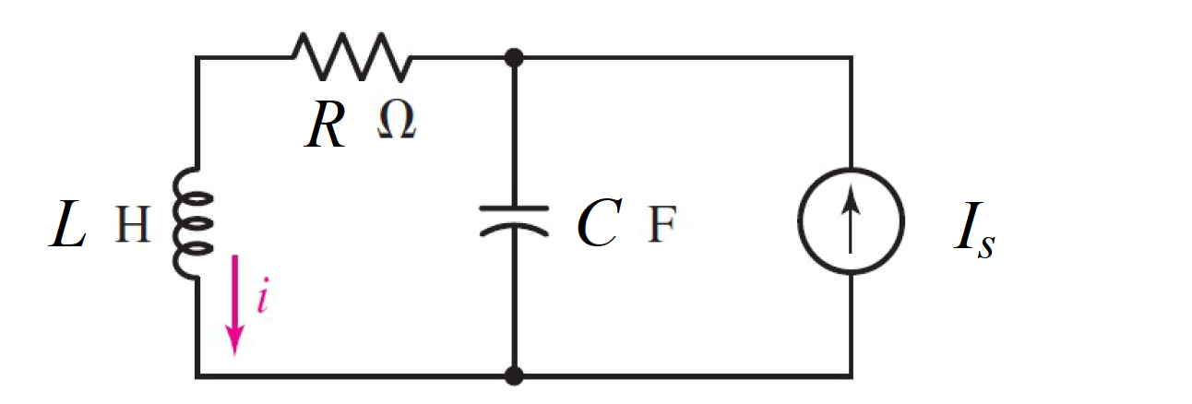

Given Is = 0.5 *u(-t) A*, r= 140 Ω, c = 0.5 F, l= 12 H Find

Variables

Random variables

#l < 4*r*r*c Parallel, c < 4*r*r/l Series

is = {0.1:2:0.1};

r = {100:200:10};

l = {10:15};

c = {0.1:0.5:0.1};

Global variables

#is = 0.5 ; r = 140; c = 0.5;

l = 12; time = 1;

# t = 0-

il0 = is;

vc0 = is*r;

# t = 0+

rth = r;

alpha = rth/(2*l);

w0 = 1/sqrt(l*c);

S1 = -alpha+sqrt(alpha*alpha-w0*w0);

S2 = -alpha-sqrt(alpha*alpha-w0*w0);

vl0=il0*r-vc0;

A1 = ((vl0/l)-(S2*il0))/(S1-S2);

A2 = il0-A1;

ilt = A1exp(S1*time)+A2exp(S2*time);

Part (กรอกคำตอบ)

1. *iL*(0-) = il0 = 0.5A

2. *vc*(0-) = vc0 = 70 V

3. *α* = alpha = 140 s^-1

4. *ω*0 = w0 = 0.4082 rad/s

At *t* > 0

5. *iL*(*t*) = A1exp(S1*t)+A2exp(S2*t)

= 0.5exp(-0.6 x10-3*t) – 1.07 x10-6exp(-279.99*t) V

6. *iL*(time*τ*) = ilt = 0.499 V